|  |
| --- |
| MOBILE APPLICATIONS DEVELOPMENT LAB  CSLR-34 |

|  |  |
| --- | --- |
| 29/04/2021 | Lab 9 |

Submitted By: -

**Supria Basak**

**106118116**

**CSE**

QUESTION-1: Design an Android application for Course Registration using Android Studio with the following specifications.

Design an Android application using Android Studio with the following specifications.

i) Image naming game - Have 6 different images and 6 textviews with the name of the images. The user can drag the text and place it on the images. Have a button, upon clicking check whether the image matches with the text. Have menu items for exiting the game, and refreshing the game.

ii) Upon matching (player wins or loses), display the notification and restart the game. Upon clicking on the notification, redirect to a page with score card which displays previous 3 results of the user.

**EXPERIMENT NAME**: Drag and Drop Usage in App.

**AIM:** To create a Drag and Drop App.

**DESCRIPTION OF APP:**

* The current app, designed using android studio, is a game which have 6 textboxes having some names of the images in random order and below 6 images and above them with background of above-mentioned names but shuffled.
* We have to drag each name of the image and drop the button which we feel it’s right match and after dropping names on all 6 images, on entering submit button we get our score (no. of correct matches) as a notification and if we click on that notification, we go to another activity showing last 3 scores of our game.
* It also has Menu with 3 options “Refresh”,” Exit”,” New Game” where refresh resets all the dropped options and new game starts new game with another set of colors and exit option exits the application.

**DEVICE SPECIFICATION:**

**Device Name: -** Samsung S10  
**Android Version: - Android 11**  
**API Level: -** 30  
**Screen Size: -** 6 inch

**TECHNICAL CONCEPTS LEARNT:**

* **Intents :** To connect activities with activities or components.
* **Explicit Intent :** To link two activites
* **Implicit Intent :** To link our activity to activities of other apps or components
* **Toast:** To show a short time pop-up message
* **Intent.putExtra :** To pass parameters using intents
* **SetOnClickListener :** To define an action when a view is clicked
* **TextView :** View related to showing text
* **Button :** Viewto perform actions when clicked on them
* **RadioGroup :** To group department choices
* **RadioButton :** To show department choices
* To use drag and drop listeners and apply them in the app.
* To use shared preferences.
* To create Menu.
* To send notifications in a channel and on clicking it redirecting to new activity using Intents.

**SOURCE CODE:**

**MainActivity.java**

package com.example.nametheimage;  
  
import androidx.annotation.RequiresApi;  
import androidx.appcompat.app.AppCompatActivity;  
import androidx.core.app.NotificationCompat;  
import androidx.core.app.NotificationManagerCompat;  
import android.app.Notification;  
import android.app.PendingIntent;  
import android.content.ClipData;  
import android.content.Context;  
import android.content.Intent;  
import android.content.SharedPreferences;  
import android.os.Build;  
import android.os.Bundle;  
import android.view.DragEvent;  
import android.view.Menu;  
import android.view.MenuItem;  
import android.view.MotionEvent;  
import android.view.View;  
import android.widget.Button;  
import android.widget.ImageView;  
import android.widget.TextView;  
import android.widget.Toast;  
import org.w3c.dom.Text;  
import java.util.Random;  
public class MainActivity extends AppCompatActivity {  
 public static Integer[] *mThumbIds* =  
 {R.drawable.*blue*,R.drawable.*pink*,R.drawable.*green*,R.drawable.*teal*,R.drawable.*red*,R.drawable.*yellow*};  
 public static String[] *s*={"blue","pink","green","teal","red","yellow"};  
 TextView t1,t2,t3,t4,t5,t6,a1,a2,a3,a4,a5,a6;  
 ImageView c1,c2,c3,c4,c5,c6;  
 Button submit;  
 NotificationManagerCompat notificationManager;  
 int score;  
 String s1="NP",s2="NP",s3="NP";  
 @Override  
 protected void onCreate(Bundle savedInstanceState) {  
 super.onCreate(savedInstanceState);  
 setContentView(R.layout.*activity_main*);  
 t1 = findViewById(R.id.*t1*);  
 t2 = findViewById(R.id.*t2*);  
 t3 = findViewById(R.id.*t3*);  
 t4 = findViewById(R.id.*t4*);  
 t5 = findViewById(R.id.*t5*);  
 t6 = findViewById(R.id.*t6*);  
 c1 = findViewById(R.id.*c1*);  
 c1.setTag(1);  
 c2 = findViewById(R.id.*c2*);  
 c2.setTag(2);  
 c3 = findViewById(R.id.*c3*);  
 c3.setTag(3);  
 c4 = findViewById(R.id.*c4*);  
 c4.setTag(4);  
 c5 = findViewById(R.id.*c5*);  
 c5.setTag(5);  
 c6 = findViewById(R.id.*c6*);  
 c6.setTag(6);  
 submit = findViewById(R.id.*submit*);  
 a1 = findViewById(R.id.\a1);  
 a1.setTag(7);  
 a2 = findViewById(R.id.a2);  
 a2.setTag(8);  
 a3 = findViewById(R.id.a3);  
 a3.setTag(9);  
 a4 = findViewById(R.id.a4);  
 a4.setTag(10);  
 a5 = findViewById(R.id.a5);  
 a5.setTag(11);  
 a6 = findViewById(R.id.a6);  
 a6.setTag(12);  
 shuffleArray(6);  
 t1.setText(*s*[0]);  
 t2.setText(*s*[1]);  
 t3.setText(*s*[2]);  
 t4.setText(*s*[3]);  
 t5.setText(*s*[4]);  
 t6.setText(*s*[5]);  
 shuffleArray(6);  
 c1.setImageResource(image(*s*[0]));  
 c2.setImageResource(image(*s*[1]));  
 c3.setImageResource(image(*s*[2]));  
 c4.setImageResource(image(*s*[3]));  
 c5.setImageResource(image(*s*[4]));  
 c6.setImageResource(image(*s*[5]));  
 t1.setOnTouchListener(new ChoiceTouchListener());  
 t2.setOnTouchListener(new ChoiceTouchListener());  
 t3.setOnTouchListener(new ChoiceTouchListener());  
 t4.setOnTouchListener(new ChoiceTouchListener());  
 t5.setOnTouchListener(new ChoiceTouchListener());  
 t6.setOnTouchListener(new ChoiceTouchListener());  
 a1.setOnDragListener(new ChoiceDragListener());  
 a2.setOnDragListener(new ChoiceDragListener());  
 a3.setOnDragListener(new ChoiceDragListener());  
 a4.setOnDragListener(new ChoiceDragListener());  
 a5.setOnDragListener(new ChoiceDragListener());  
 a6.setOnDragListener(new ChoiceDragListener());  
 notificationManager = NotificationManagerCompat.*from*(this);  
 SharedPreferences sp = getSharedPreferences("myprefs",  
 Context.*MODE_PRIVATE*);  
 SharedPreferences.Editor ed = sp.edit();  
 if(!sp.contains("s1"))  
 {  
 ed = sp.edit();  
 ed.putString("s1",s1);  
 ed.putString("s2",s2);  
 ed.putString("s3",s3);  
 ed.commit();  
 }  
 SharedPreferences.Editor finalEd = ed;  
 submit.setOnClickListener(new View.OnClickListener() {  
 @RequiresApi(api = Build.VERSION_CODES.*M*)  
 @Override  
 public void onClick(View v) {  
  
 if(a1.getText().toString().matches("answer")||a2.getText().toString().matches("answer")||a3.getText().toString().matches("answer")||a4.getText().toString().matches("answer")||a5.getText().toString().matches("answer")||a6.getText().toString().matches("answer"))  
 {  
 Toast.*makeText*(MainActivity.this, "Please fill all the options", Toast.*LENGTH_SHORT*).show();  
 return;  
 }  
 score = 0;  
 if(a1.getText().toString().matches(*s*[0]))  
 score++;  
 if(a2.getText().toString().matches(*s*[1]))  
 score++;  
 if(a3.getText().toString().matches(*s*[2]))  
 score++;  
 if(a4.getText().toString().matches(*s*[3]))  
 score++;  
 if(a5.getText().toString().matches(*s*[4]))  
 score++;  
 if(a6.getText().toString().matches(*s*[5]))  
 score++;  
 s1 = sp.getString("s1","");  
 s2 = sp.getString("s2","");  
 s3 = sp.getString("s3","");  
 s3 = s2;  
 s2 = s1;  
 s1 = String.*valueOf*(score);  
 finalEd.putString("s1",s1);  
 finalEd.putString("s2",s2);  
 finalEd.putString("s3",s3);  
 finalEd.apply();  
 sendNotif();  
 newGame();  
 }  
 });  
 }  
 public void refresh()  
 {  
 a1.setText("answer");  
 a2.setText("answer");  
 a3.setText("answer");  
 a4.setText("answer");  
 a5.setText("answer");  
 a6.setText("answer");  
 }  
 public void newGame()  
 {  
 refresh();  
 shuffleArray(6);  
 t1.setText(*s*[0]);  
 t2.setText(*s*[1]);  
 t3.setText(*s*[2]);  
 t4.setText(*s*[3]);  
 t5.setText(*s*[4]);  
 t6.setText(*s*[5]);  
 }  
 public void sendNotif()  
 {  
 String title = "You Lost";  
 if(score==6)  
 title = "You Won";  
 String message = "Your score is "+score+"/6";  
 Intent i = new Intent(this,ScoreActivity.class);  
 PendingIntent pi =  
 PendingIntent.*getActivity*(this,1,i,PendingIntent.*FLAG_UPDATE_CURRENT*);  
 Notification notification = new NotificationCompat.Builder(this,  
 App.*CHANNEL_1_ID*)  
 .setSmallIcon(R.drawable.*ic_refresh*)  
 .setContentTitle(title)  
 .setContentText(message)  
 .setPriority(NotificationCompat.*PRIORITY_HIGH*)  
 .setCategory(NotificationCompat.*CATEGORY_MESSAGE*)  
 .setContentIntent(pi)  
 .setAutoCancel(true)  
 .build();  
 notificationManager.notify(1, notification);  
 }  
 public final class ChoiceDragListener implements View.OnDragListener{  
 @Override  
 public boolean onDrag(View v, DragEvent event) {  
 switch(event.getAction())  
 {  
 case DragEvent.*ACTION_DRAG_STARTED*:  
 break;  
 case DragEvent.*ACTION_DRAG_ENTERED*:  
 break;  
 case DragEvent.*ACTION_DRAG_EXITED*:  
 break;  
 case DragEvent.*ACTION_DRAG_ENDED*:  
 break;  
 case DragEvent.*ACTION_DROP*:  
 TextView t = (TextView) event.getLocalState();  
 String s = t.getText().toString();  
 ((TextView)v).setText(s);  
 break;  
 }  
 return true;  
 }  
 }  
 private final class ChoiceTouchListener implements View.OnTouchListener{  
 @Override  
 public boolean onTouch(View v, MotionEvent event) {  
 if((event.getAction() ==  
 MotionEvent.*ACTION_DOWN*)&&((TextView)v).getText().toString() != null)  
 {  
 ClipData data = ClipData.*newPlainText*("","");  
 View.DragShadowBuilder shadowBuilder = new  
 View.DragShadowBuilder(v);  
 v.startDrag(data,shadowBuilder,v,0);  
 return true;  
 }  
 else  
 return false;  
 }  
 }  
 public int image(String s)  
 {  
 if(s.matches("blue"))  
 return R.drawable.*blue*;  
 if(s.matches("pink"))  
 return R.drawable.*pink*;  
 if(s.matches("green"))  
 return R.drawable.*green*;  
 if(s.matches("teal"))  
 return R.drawable.*teal*;  
 if(s.matches("red"))  
 return R.drawable.*red*;  
 if(s.matches("yellow"))  
 return R.drawable.*yellow*;  
 return 0;  
 }  
 private void swap(int i, int change) {  
 String helper = *s*[i];  
 *s*[i] = *s*[change];  
 *s*[change] = helper;  
 }  
 public void shuffleArray(int n) {  
 Random random = new Random();  
 random.nextInt();  
 for (int i = 0; i < n; i++) {  
 int change = i + random.nextInt(n - i);  
 swap(i, change);  
 }  
 }  
 @Override  
 public boolean onCreateOptionsMenu(Menu menu) {  
 getMenuInflater().inflate(R.menu.*menu1*, menu);  
 return true;  
 }  
 @Override  
 public boolean onOptionsItemSelected(MenuItem item) {  
 int id = item.getItemId();  
 switch (id){  
 case R.id.*newGame*:  
 Toast.*makeText*(this, "New Game", Toast.*LENGTH_SHORT*).show();  
 newGame();  
 return true;  
 case R.id.*refresh*:  
 Toast.*makeText*(this, "Refreshed", Toast.*LENGTH_SHORT*).show();  
 refresh();  
 return true;  
 case R.id.*exit*:  
 Toast.*makeText*(this, "Exiting", Toast.*LENGTH_SHORT*).show();  
 finish();  
 return true;  
 default:  
 return super.onOptionsItemSelected(item);  
 }  
 }  
}

**Activity_main.xml**

<?xml version="1.0" encoding="utf-8"?>  
<LinearLayout xmlns:android="http://schemas.android.com/apk/res/android"  
 xmlns:app="http://schemas.android.com/apk/res-auto"  
 xmlns:tools="http://schemas.android.com/tools"  
 android:layout_width="match_parent"  
 android:layout_height="match_parent"  
 tools:context=".MainActivity"  
 android:orientation="vertical">  
 <TextView  
 android:layout_width="wrap_content"  
 android:layout_height="wrap_content"  
 android:text="Drag and drop Names"  
 android:textSize="30sp"  
 android:layout_marginVertical="20dp"  
 android:textStyle="bold|italic"  
 android:background="@color/purple_200"  
 android:layout_gravity="center_horizontal"  
 android:textColor="#F4AA12"/>  
  
 <LinearLayout  
 android:layout_width="407dp"  
 android:layout_height="wrap_content"  
 android:layout_gravity="center"  
 android:layout_marginVertical="20dp"  
 android:orientation="horizontal">  
  
 <TextView  
 android:id="@+id/t1"  
 android:layout_width="80dp"  
 android:layout_height="wrap_content"  
 android:layout_marginHorizontal="30dp"  
 android:background="@color/purple_200"  
 android:text="Hello"  
 android:textColor="@color/black"  
 android:textSize="25sp" />  
  
 <TextView  
 android:id="@+id/t2"  
 android:layout_width="77dp"  
 android:layout_height="wrap_content"  
 android:layout_marginHorizontal="30dp"  
 android:background="@color/purple_200"  
 android:text="Hello"  
 android:textColor="@color/black"  
 android:textSize="25sp" />  
  
 <TextView  
 android:id="@+id/t3"  
 android:layout_width="80dp"  
 android:layout_height="wrap_content"  
 android:layout_marginHorizontal="30dp"  
 android:background="@color/purple_200"  
 android:text="Hello"  
 android:textColor="@color/black"  
 android:textSize="25sp" />  
 </LinearLayout>  
 <LinearLayout  
 android:layout_width="wrap_content"  
 android:layout_height="wrap_content"  
 android:orientation="horizontal"  
 android:layout_marginVertical="20dp"  
 android:layout_gravity="center">  
  
 <TextView  
 android:id="@+id/t4"  
 android:layout_width="79dp"  
 android:layout_height="wrap_content"  
 android:layout_marginHorizontal="30dp"  
 android:background="@color/purple_200"  
 android:text="Hello"  
 android:textColor="@color/black"  
 android:textSize="25sp" />  
  
 <TextView  
 android:id="@+id/t5"  
 android:layout_width="83dp"  
 android:layout_height="wrap_content"  
 android:layout_marginHorizontal="30dp"  
 android:background="@color/purple_200"  
 android:text="Hello"  
 android:textColor="@color/black"  
 android:textSize="25sp" />  
  
 <TextView  
 android:id="@+id/t6"  
 android:layout_width="79dp"  
 android:layout_height="wrap_content"  
 android:layout_marginHorizontal="30dp"  
 android:background="@color/purple_200"  
 android:text="Hello"  
 android:textColor="@color/black"  
 android:textSize="25sp" />  
 </LinearLayout>  
 <LinearLayout  
 android:layout_width="wrap_content"  
 android:layout_height="wrap_content"  
 android:orientation="horizontal"  
 android:layout_marginTop="60dp"  
 android:layout_gravity="center">  
 <FrameLayout  
 android:layout_width="wrap_content"  
 android:layout_height="wrap_content">  
 <ImageView  
 android:src="@drawable/blue"  
 android:layout_width="100dp"  
 android:layout_height="60dp"  
 android:scaleType="fitCenter"  
 android:layout_marginHorizontal="10dp"  
 android:id="@+id/c1"/>  
  
 </FrameLayout>  
 <FrameLayout  
 android:layout_width="wrap_content"  
 android:layout_height="wrap_content">  
 <ImageView  
 android:src="@drawable/pink"  
 android:layout_width="100dp"  
 android:layout_height="60dp"  
 android:scaleType="fitCenter"  
 android:layout_marginHorizontal="10dp"  
 android:id="@+id/c2"/>  
 </FrameLayout>  
 <FrameLayout  
 android:layout_width="wrap_content"  
 android:layout_height="wrap_content">  
 <ImageView  
 android:src="@drawable/green"  
 android:layout_width="100dp"  
 android:layout_height="60dp"  
 android:scaleType="fitCenter"  
 android:layout_marginHorizontal="10dp"  
 android:id="@+id/c3"/>  
 </FrameLayout>  
 </LinearLayout>  
 <LinearLayout  
 android:layout_width="wrap_content"  
 android:layout_height="wrap_content"  
 android:orientation="horizontal"  
 android:layout_marginTop="40dp"  
 android:layout_gravity="center">  
  
 <FrameLayout  
 android:layout_width="wrap_content"  
 android:layout_height="wrap_content">  
  
 <ImageView  
 android:id="@+id/c4"  
 android:layout_width="100dp"  
 android:layout_height="60dp"  
 android:layout_marginHorizontal="10dp"  
 android:scaleType="fitCenter"  
 android:src="@drawable/teal" />  
 </FrameLayout>  
  
 <FrameLayout  
 android:layout_width="wrap_content"  
 android:layout_height="wrap_content">  
 <ImageView  
 android:src="@drawable/red"  
 android:layout_width="100dp"  
 android:layout_height="60dp"  
 android:scaleType="fitCenter"  
 android:layout_marginHorizontal="10dp"  
 android:id="@+id/c5"/>  
 </FrameLayout>  
 <FrameLayout  
 android:layout_width="wrap_content"  
 android:layout_height="wrap_content">  
  
 <ImageView  
 android:id="@+id/c6"  
 android:layout_width="72dp"  
 android:layout_height="60dp"  
 android:layout_marginHorizontal="10dp"  
 android:scaleType="fitCenter"  
 android:src="@drawable/yellow" />  
  
 </FrameLayout>  
 </LinearLayout>  
 <Button  
 android:layout_width="wrap_content"  
 android:layout_height="wrap_content"  
 android:layout_gravity="center_horizontal"  
 android:text="Submit"  
 android:backgroundTint="@color/teal_200"  
 android:layout_marginTop="50dp"  
 android:id="@+id/submit" />  
</LinearLayout>

**App.java:**

package com.example.nametheimage;  
  
import android.app.Application;  
import android.app.NotificationChannel;  
import android.app.NotificationManager;  
import android.os.Build;  
public class App extends Application {  
 public static final String *CHANNEL_1_ID* = "channel1";  
 @Override  
 public void onCreate() {  
 super.onCreate();  
 createNotificationChannels();  
 }  
 private void createNotificationChannels() {  
 if (Build.VERSION.*SDK_INT* >= Build.VERSION_CODES.*O*) {  
 NotificationChannel channel1 = new NotificationChannel(  
 *CHANNEL_1_ID*,  
 "Channel 1",  
 NotificationManager.*IMPORTANCE_HIGH* );  
 channel1.setDescription("This is Channel 1");  
 NotificationManager manager =  
 getSystemService(NotificationManager.class);  
 manager.createNotificationChannel(channel1);  
 }  
 }  
}

**ScoreActivity.java**

package com.example.nametheimage;  
  
import androidx.appcompat.app.AppCompatActivity;  
import android.content.Context;  
import android.content.SharedPreferences;  
import android.os.Bundle;  
import android.widget.TextView;  
public class ScoreActivity extends AppCompatActivity {  
 TextView s1,s2,s3;  
 @Override  
 protected void onCreate(Bundle savedInstanceState) {  
 super.onCreate(savedInstanceState);  
 setContentView(R.layout.*activity_score*);  
 s1 = findViewById(R.id.*s1*);  
 s2 = findViewById(R.id.*s2*);  
 s3 = findViewById(R.id.*s3*);  
 SharedPreferences sp = getSharedPreferences("myprefs",  
 Context.*MODE_PRIVATE*);  
 s1.setText(sp.getString("s1",""));  
 s2.setText(sp.getString("s2",""));  
 s3.setText(sp.getString("s3",""));  
 }  
}

**activity_score.xml**

<?xml version="1.0" encoding="utf-8"?>  
<LinearLayout xmlns:android="http://schemas.android.com/apk/res/android"  
 xmlns:app="http://schemas.android.com/apk/res-auto"  
 xmlns:tools="http://schemas.android.com/tools"  
 android:layout_width="match_parent"  
 android:layout_height="match_parent"  
 tools:context=".ScoreActivity"  
 android:orientation="vertical">  
 <TextView  
 android:layout_width="wrap_content"  
 android:layout_height="wrap_content"  
 android:text="Your last 3 scores are"  
 android:textSize="30sp"  
 android:layout_marginVertical="20dp"  
 android:textStyle="bold|italic"  
 android:layout_gravity="center_horizontal"  
 android:textColor="@color/black"/>  
 <TextView  
 android:layout_width="wrap_content"  
 android:layout_height="wrap_content"  
 android:textSize="20sp"  
 android:id="@+id/s1"  
 android:layout_gravity="center_horizontal"  
 android:layout_marginVertical="20dp"  
 android:textColor="@color/black"/>  
 <TextView  
 android:layout_width="wrap_content"  
 android:layout_height="wrap_content"  
 android:textSize="20sp"  
 android:id="@+id/s2"  
 android:layout_gravity="center_horizontal"  
 android:layout_marginVertical="20dp"  
 android:textColor="@color/black"/>  
 <TextView  
 android:layout_width="wrap_content"  
 android:layout_height="wrap_content"  
 android:textSize="20sp"  
 android:id="@+id/s3"  
 android:layout_gravity="center_horizontal"  
 android:layout_marginVertical="20dp"  
 android:textColor="@color/black"/>  
</LinearLayout>

**Menu1.xml**

<?xml version="1.0" encoding="utf-8"?>  
<menu xmlns:android="http://schemas.android.com/apk/res/android">  
 <item  
 android:id="@+id/newGame"  
 android:title="New Game"/>  
 <item  
 android:id="@+id/refresh"  
 android:title="Refresh" />  
 <item  
 android:id="@+id/exit"  
 android:title="Exit"/>  
</menu>

**AndroidManifest.xml**

<?xml version="1.0" encoding="utf-8"?>  
<manifest xmlns:android="http://schemas.android.com/apk/res/android"  
 package="com.example.nametheimage">  
  
 <application  
 android:name=".App"  
 android:allowBackup="true"  
 android:icon="@mipmap/ic_launcher"  
 android:label="@string/app_name"  
 android:roundIcon="@mipmap/ic_launcher_round"  
 android:supportsRtl="true"  
 android:theme="@style/Theme.NameTheImage">  
 <activity android:name=".ScoreActivity"></activity>  
 <activity android:name=".MainActivity">  
 <intent-filter>  
 <action android:name="android.intent.action.MAIN" />  
 <category android:name="android.intent.category.LAUNCHER" />  
 </intent-filter>  
 </activity>  
 </application>  
</manifest>

**Screenshot:**

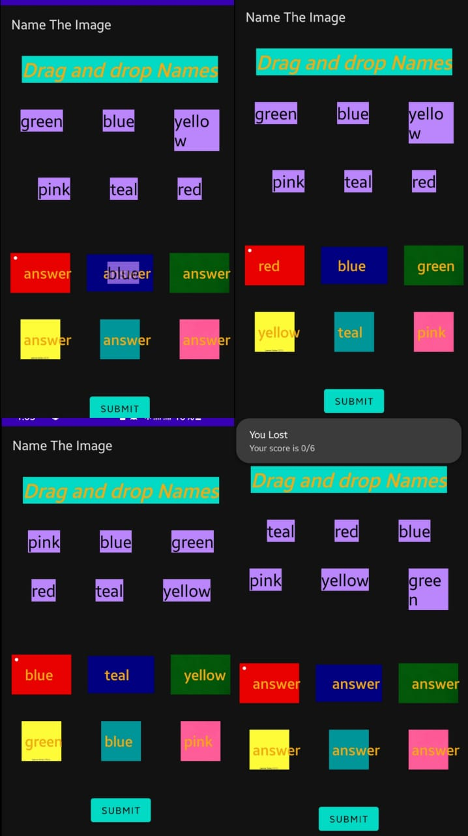

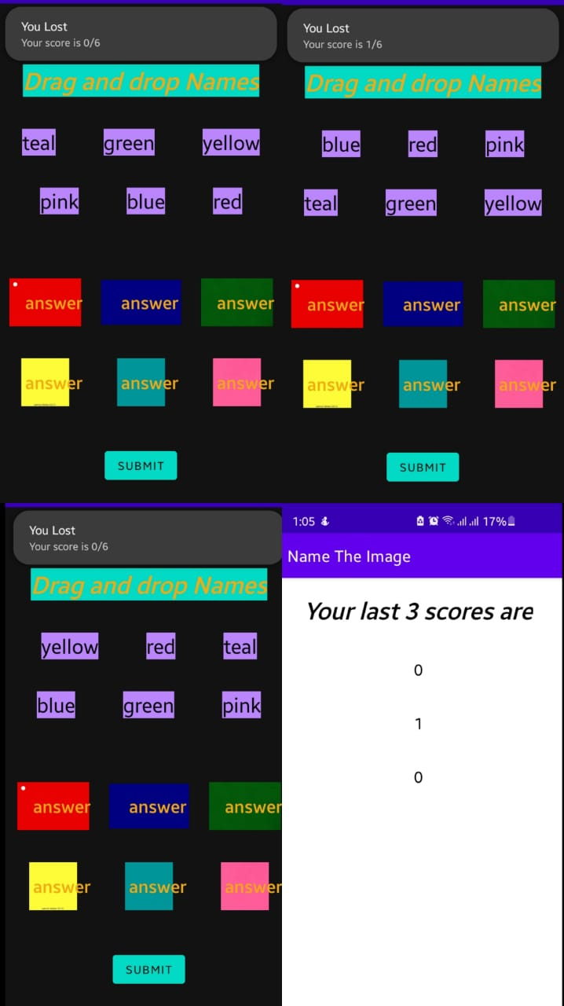

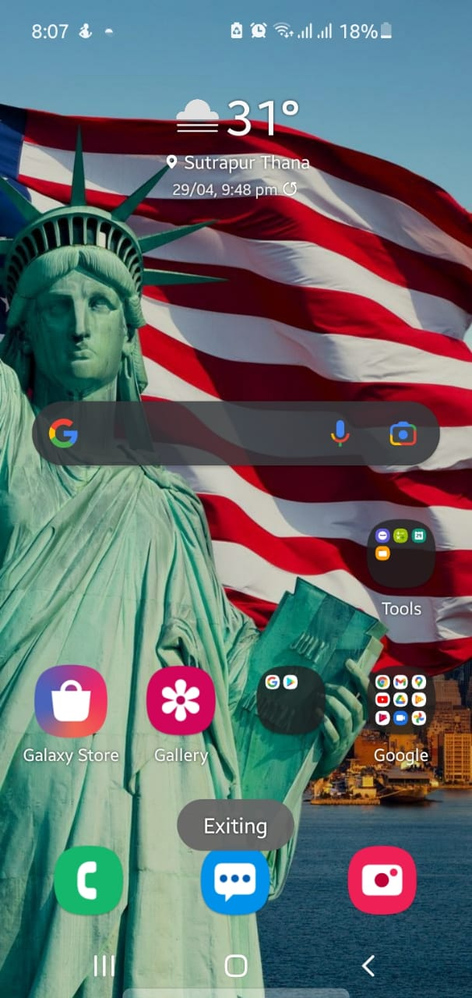

**Outcome:**

* Intent, Implicit Intent, Explicit Intent, Button views, Radio Group, Radio Button are used to build this application successfully.
* All specifications are successfully executed.
* I learned AVD manager functionality.